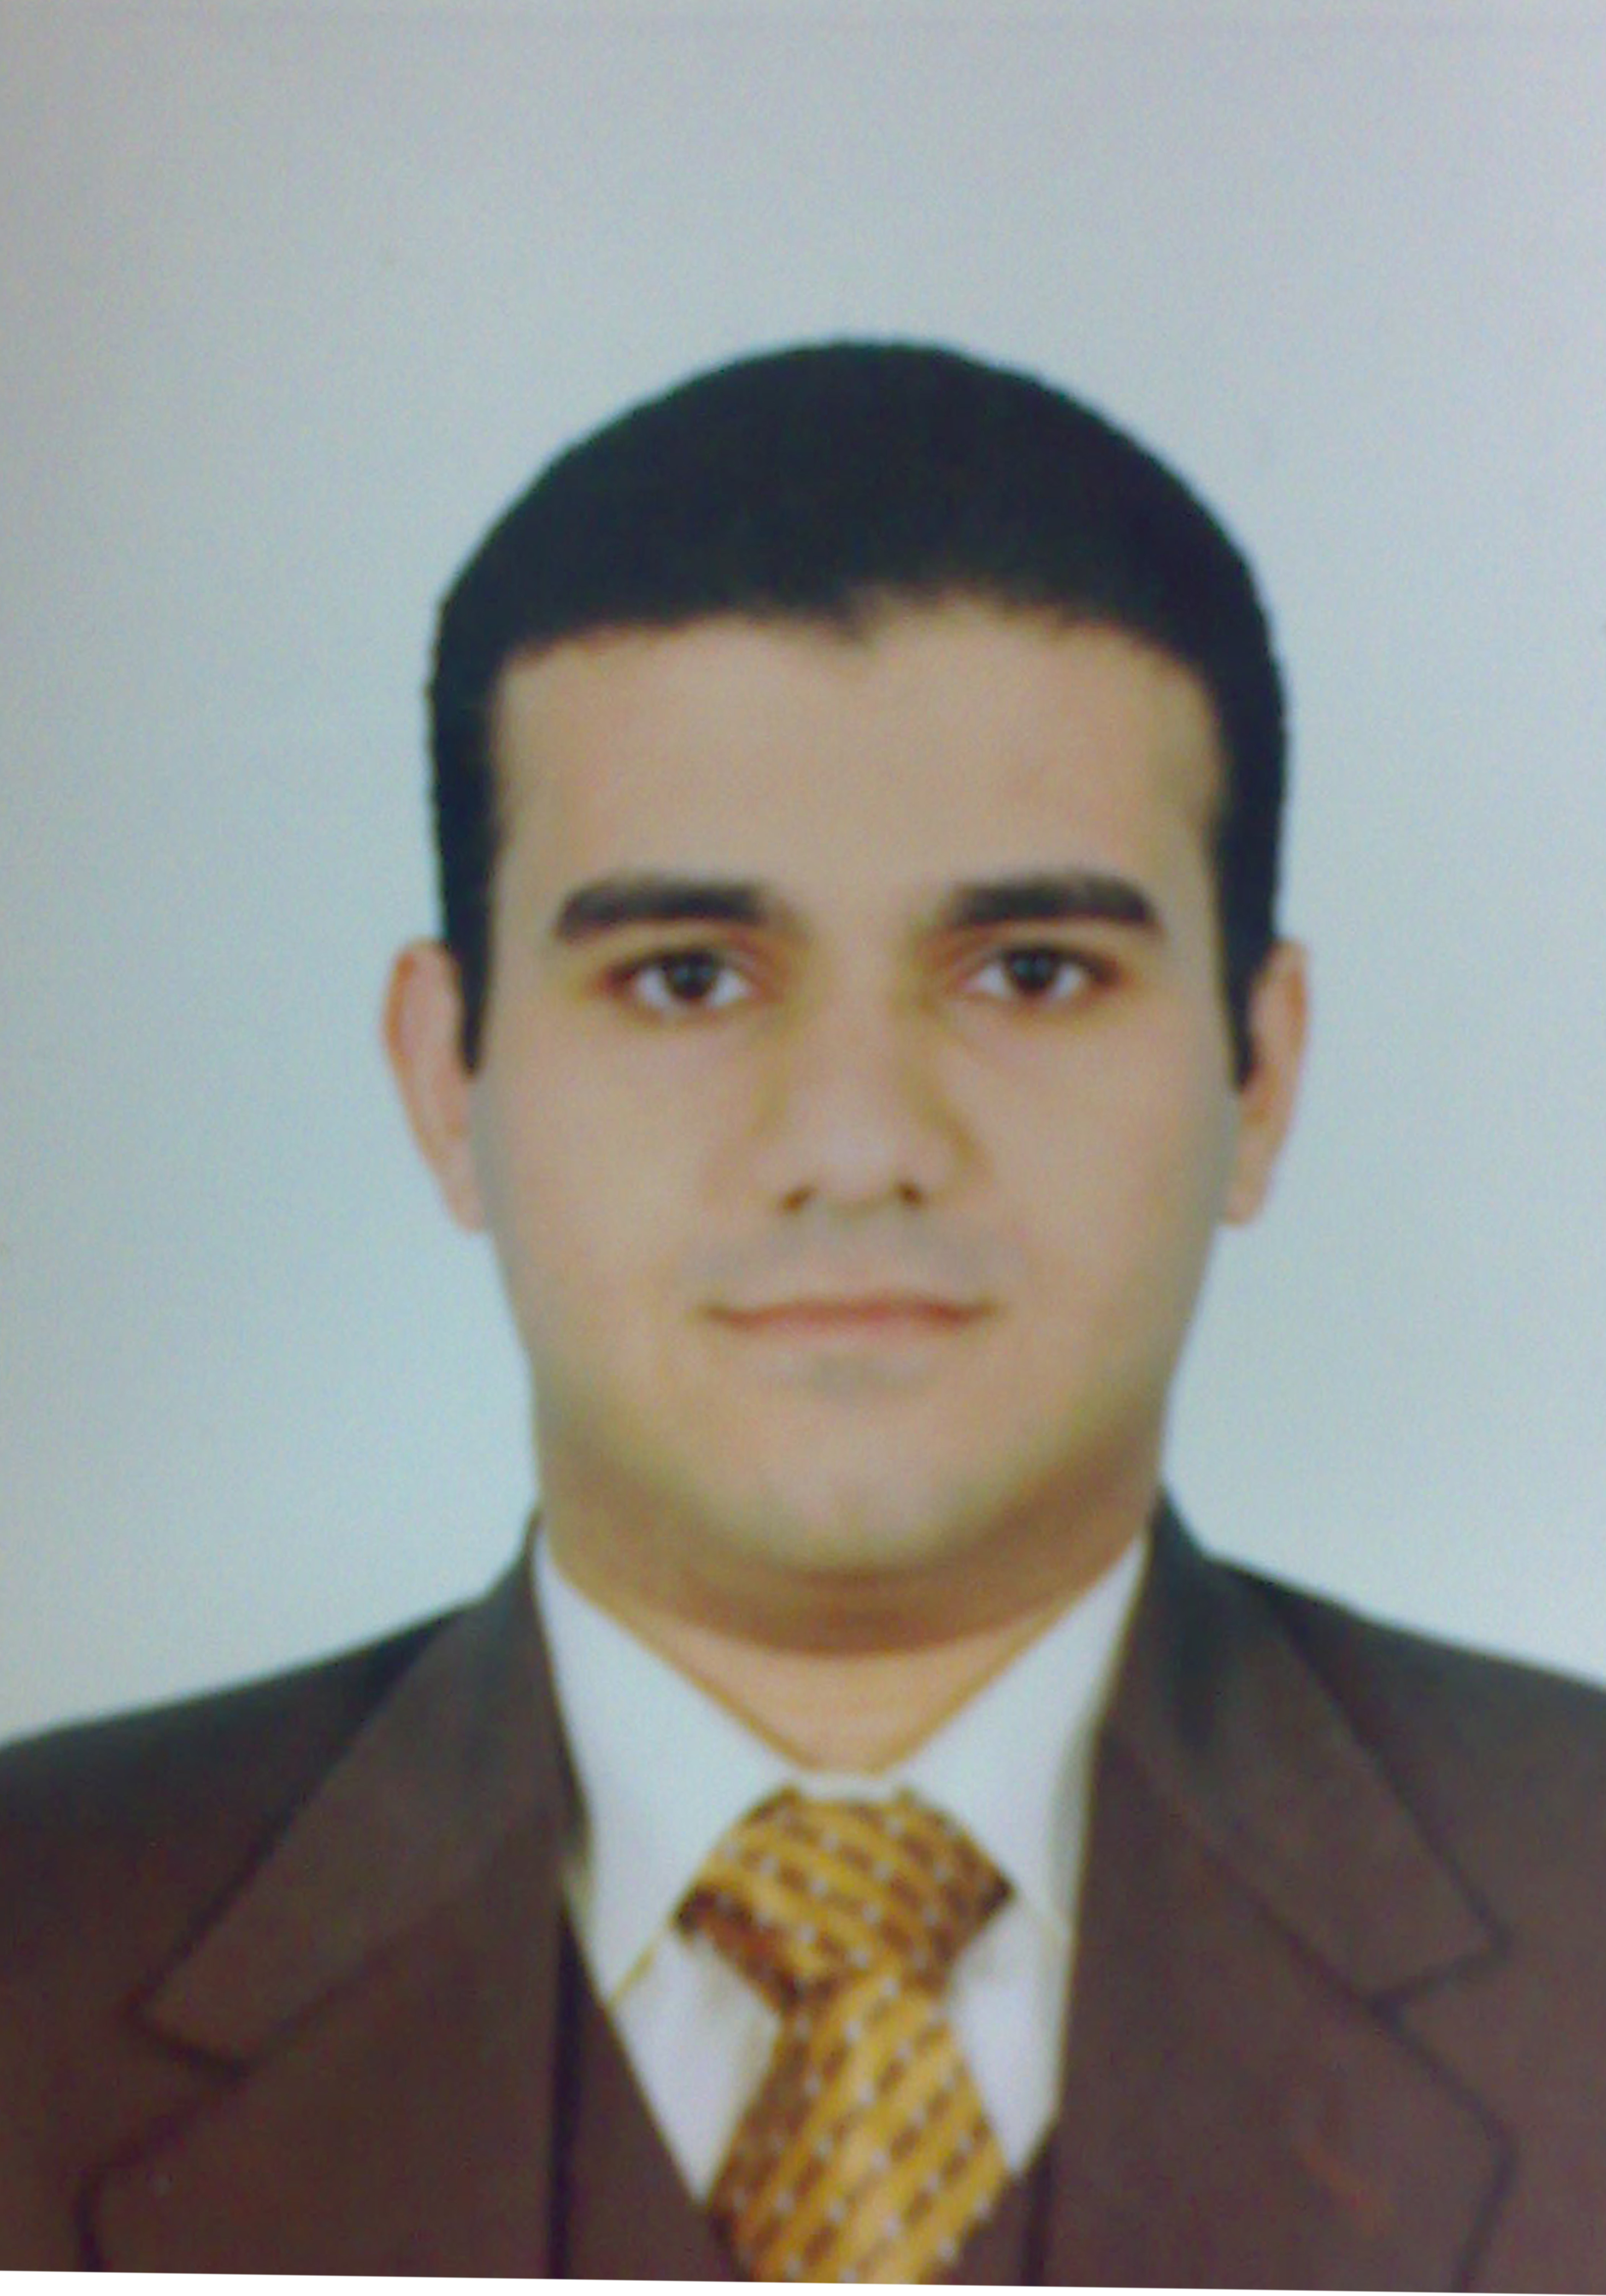
Personal information:
- Name: Michel Effat Fakhry Abd El-Massieh.
- Nationality: Egyptian
- Title/Rank: Lecturer of medical biochemistry and molecular biology, M.D.
- Tel.: Work 002-088-2411988,
Home 002-088-2285367,
Mobile 002-01286195641 / 002-01146005463
- E-mail: mikelfakhry@yahoo.com or mikelfakhry@gmail.com
- Date and place of birth: Jan.14, 1981, Assiut, Egypt.
- Work Address: medical biochemistry department, faculty of medicine, Assiut University, Assiut, Egypt.
- Specialization: Medical Biochemistry, Molecular biology and Cancer biology.
- Current Home Address: 33 Goda El Asdy street, Assuit, Egypt.
- Marital Status: Married.
- Disabilities and chronic illness: none.
- Languages: Arabic/English: Excellent reading, writing and conversation.

Qualifications
- Bachelor of Medicine and Surgery, Faculty of Medicine, Assiut University, Assiut, Egypt. September, 2003.
- M.Sc. (Medical Biochemistry): Essay entitled: Some New Biochemical Markers of Chronic Liver Diseases, 2009, Faculty of Medicine, Assiut unv, Assiut, Egypt.
- M.D. (Medical Biochemistry): Thesis entitled: Diagnostic and Prognostic biomarkers of colorectal cancer, 2015, Faculty of Medicine, Assiut University, Assiut, Egypt.

Experiences
A. Teaching:
- Demonstrator and Assistant lecturer of Medical Biochemistry, 2005- 2015.
I had got the following skills during this period:
  - Teaching the laboratory experiments for medical students
  - Simplifying the theoretical issues to be easily understood
  - Dealing with students problems and tackling them.
  - Performing the laboratory experiments
  - Preparing the solutions needed for the laboratory work
  - Using the following techniques: spectrophotometry, EIIZA readers, flame photometry, centrifugation, manual and automatic pipetting.
  - Advanced user of all computer applications.
  - Making all statistical analysis of scientific data.
  - Browsing internet databases for scientific literatures.
  - Improving scientific discussion during time course of lectures and use instructing facilities, projectors and data show.
  - Had local TOEFL with score of 597.

B- Conferences:
- I participated in the organization and attended the following conferences:
  - The 25th annual conference of Faculty of Medicine, Assiut University, Assiut, Egypt, in 11-14 March, 2007.
  - The 1st Scientific Conference of Medical Biochemistry Department, Faculty of Medicine, Assiut University, Assiut, Egypt, in 21 – 23 December, 2005.
  - The 2nd Scientific Conference of Medical Biochemistry Department, Faculty of Medicine, Assiut University, Assiut, Egypt, in 16 – 17 March, 2007.
- I participated in the following conferences:
  - The 26th annual conference of Faculty of Medicine, Assiut University, Assiut, Egypt, in 8 - 11 March, 2007.
  - The 2nd annual scientific Conference of The Egyptian Association of Viral Hepatitis, Assiut, Egypt, in 20 – 21 November, 2007.
Published works:
- Thorya El-Deeb, Amany Osama, Doaa W. Maximous, Osman M. Essam & Michel E. Fakhry: A biochemical study on some biomarkers of colorectal cancer, Journal of Medical Molecular Biotechnology; 13, 2015.

